WEEK 6 – GIT
Submitted By: Priyanshu Shekhar
Superset ID: 8011160
College: C. V. Raman Global University, Odisha
Registration No.: 2301020267
Email: shekharpriyanshu21@gmail.com

Please follow the instructions to complete the hands-on. Each instruction expects a command for the Git Bash.
- Verify if master is in clean state.
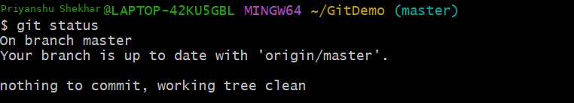
- List out all the available branches.
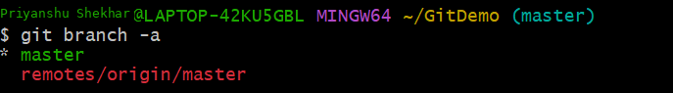
- Pull the remote git repository to the master
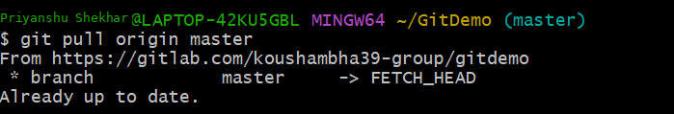
- Push the changes, which are pending from “Git-T03-HOL_002” to the remote repository.
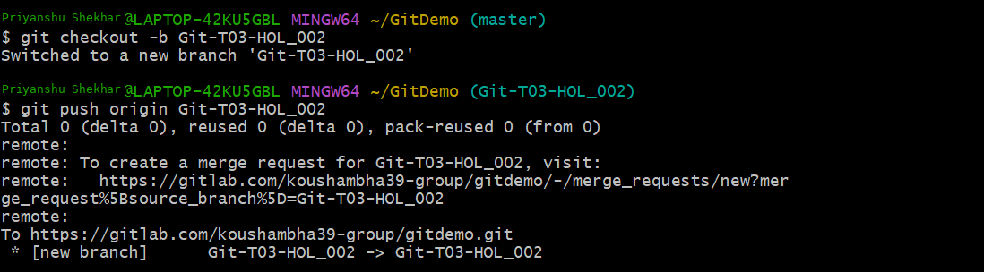

- Observe if the changes are reflected in the remote repository.
